NE-NJ-NYSS-AAPT
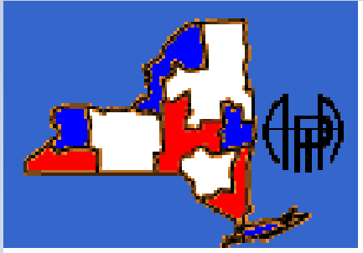
2013 Fall Meeting Registration
September 27+28 2013
Host Marist College
Name:______________________
Address: _____________________
_____________________
_____________________
_____________________
Email Address __________________________
Meeting Fee: Circle One
Early Bird $20 Day Of $25 Student $10

Banquet Fee(Grand Hotel 8:00PM September 27th, Open to All) - $30 Per Person $30 + $30*Number of Guests____ Total _______

Membership: Circle One
Current Member NYSS NESS NJSS 0 Non-member $10

Workshops with extra fees:

PTRA Workshop: (Limited to 20 Participants) $30
LED Photoelectric Workshop $30

Total__________ Make Checks Payable to NYSS-AAPT

Mail To: Robert Stewart 14 Valley Rd, Forestburgh NY 12777, also please email a copy of this form to rstewart1@hvc.rr.com.

